PHASE 8 OF 8
Project Execution and API Testing
Running the backend and verifying each API with Postman.
1. Running the Backend Server
Before running, make sure MongoDB is running and the environment variables are set. Then install the dependencies:
npm install
Start the development server:
npm start
After successful execution, the server connects to MongoDB and starts listening for API requests. The APIs can be tested with Postman or Thunder Client.
2. API Testing
Register API
POST /api/auth/register with name, email and password creates a new user and returns a success response with a JWT token.

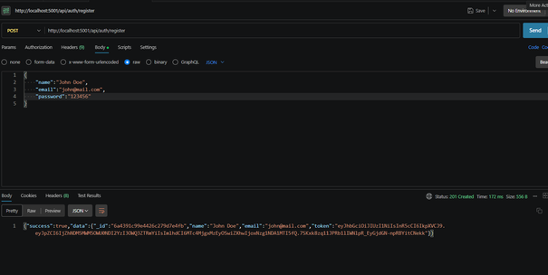

Figure 8.1 - Register API in Postman
Login API
POST /api/auth/login with email and password authenticates the user and returns a token.

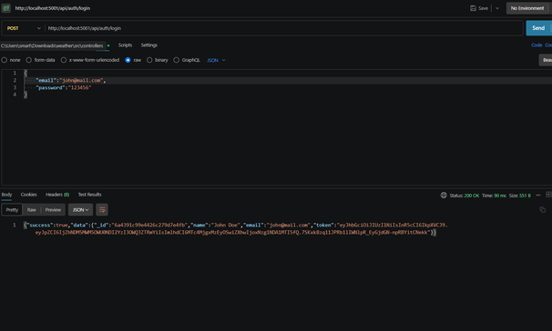

Figure 8.2 - Login API in Postman
Weather API
GET /api/weather/bangalore returns the current weather data (city, temperature, humidity, wind speed and condition).

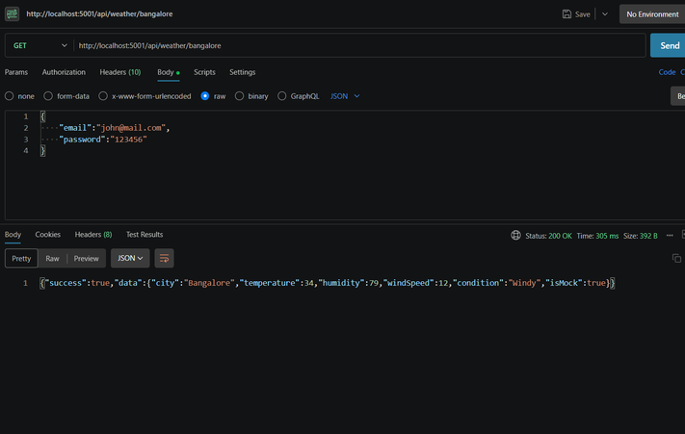

Figure 8.3 - Weather API in Postman
Recommendation API
POST /api/ai/weather-recommendation takes the city and current conditions and returns an AI-generated recommendation.

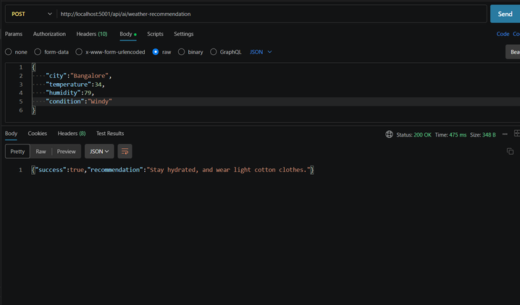

Figure 8.4 - Recommendation API in Postman

AI WeatherWise | Phase 8: Project Execution and API Testing | Page

